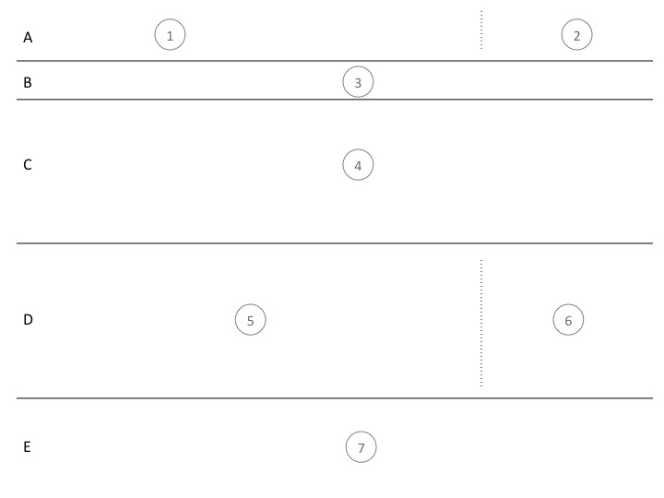

**Sections:**

A - Header

B - Main Menu

C - Marketing

D - Social media/Aggregated feeds (blogs, twitter, etc)

E - Detailed Menu

**Content:**

1. Driven Logo
2. Customer endorsement (random on refresh)
3. Menu
   1. Home
   2. About Us
   3. Client Portfolio
   4. What we do
   5. Resources
   6. Contact us
4. Advertising/Blurb – something we can change regularly to keep the site looking fresh
5. Aggregated feed of all Driven Software employee blogs
6. The Driven Software twitter feed
7. Detailed menu
   1. About us
      1. Our history
      2. Our People
      3. Our approach
   2. Client portfolio
      1. View all
   3. What we do
      1. Immersive Coaching
      2. Consulting
      3. Training
   4. Resources
      1. Training Material
      2. Podcast (?)
      3. Blogs
      4. Open Source Projects
      5. etc